1. Create a blog or website using Blogspot and Wordpress. Customize the theme design and post new article with 500 words.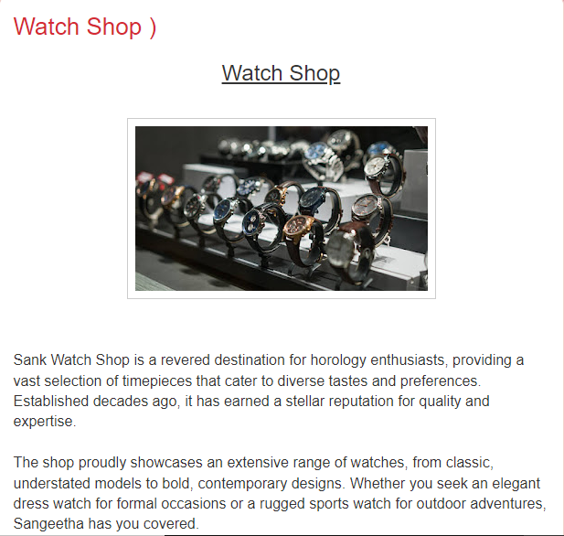

Sank watch shop-<https://sankwatchshop.blogspot.com/2023/10/watch-shop.html>

1. Create a New Facebook Business Page and post one social media poster for your brand.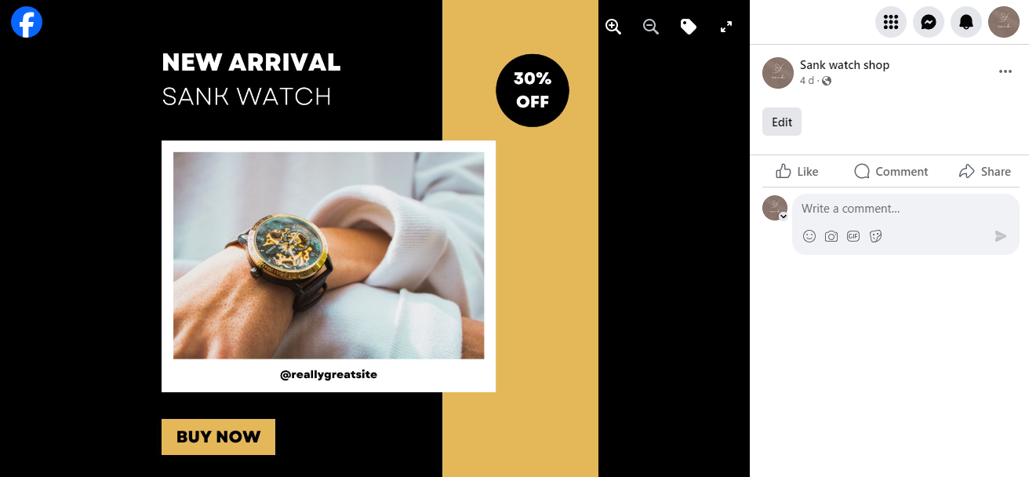

Sank watch shop facebook page-<https://www.facebook.com/profile.php?id=61552285953765&is_tour_dismissed=true>

3.Create and design a social media advertisement poster using canva.



4.Create email newsletter design using MailChimp or canva tool.

